2nd Sunday after the Epiphany
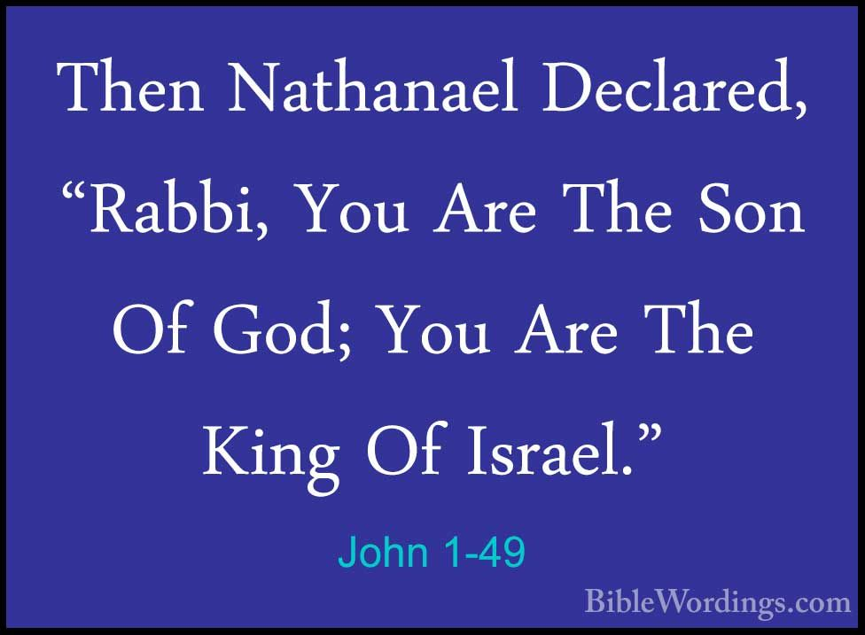

10 A. M. Worship for Sunday, January 14, 2024
First Memorial Presbyterian Church of Dover, New Jersey

Gathering and Focusing during Prelude: - Rachel Persenaire
Thank you for choosing to worship our Lord and Savior Jesus Christ with us today!
*We invite you to stand if you are able for those portions of the liturgy marked with an asterisk.

xx
*Sung Approach to Worshiping Our God: - Rachel Persenaire
“The Longer I Serve Him” - William J. Gaither, 1965
1. Since I started for the Kingdom, Since my life He controls,
Since I gave my heart to Jesus,
The longer I serve Him, the sweeter He grows.

Refrain: The longer I serve Him, the sweeter He grows.
The more that I love Him, more love He bestows.
Each day is like heaven, my heart overflows.
The longer I serve Him, the sweeter He grows.

2. Every need He is supplying; Plenteous grace He bestows.
Every day my way gets brighter;
The longer I serve Him, the sweeter He grows. Refrain

- © 1965 by William J. Gaither. All rights reserved. Conditional use granted by C. C. L. I. license #970294
As found in THE CELEBRATION HYMNAL, Word Music as Hymn No. 520.

Opening Words: - Rachel Persenaire
Rachel: The one who calls you together this day
yearns for each of you and for all people
to hear and be blessed.
All: Speak, Lord, for your servants are listening. - 1 Samuel 3:9
Rachel: Blessed is the One who comes bringing trustworthy words
for the healing of the world.
All: Speak, Lord, for your servants are listening. - 1 Samuel 3:9
- The Opening Words (above) are as found on page 50. of Feasting On the Word, Liturgies for Year B, vol.1.
© 2014, by WESTMINSTER JOHN KNOX PRESS, Louisville, KY. All rights reserved. Used with the permission.

Call to Confession:
Alan: (Good morning Saints,)
Assured that the One who calls us to hear and obey
already knows the confessions of our hearts
and is ready to forgive,
let us confess our sin before God and one another…

Corporate Prayer of Confession:
Alan: (Let us pray…)
All: Holy God, you see into each of us and know us fully
as creatures in need of your constant care.

We confess that we have neither heard your word
nor followed your will.

We have failed our nation, neighbors, families, friends,
and ourselves

Give us ears to hear your wisdom.

Lead us to honesty and faith so that we may begin again
with renewed strength; in Jesus’ name. Amen.

(We pause here for a few moments of silent, personal confession…)

Assurance of Pardon:
Alan: God knows the hearts of those who seek forgiveness,

And by grace you have been saved.

In Jesus’ name you are forgiven.

Your sins are no more.

You have been made clean.

God strengthens you with freedom through the Holy Spirit,
in Christ Jesus.

All: (Thanks be to God! Amen.)

- The Call to Confession, Prayer of Confession and Assurance of Pardon (above) are as found on pages 50 & 51.
of Feasting On the Word, Liturgies for Year B, vol.1.
© 2014, by WESTMINSTER JOHN KNOX PRESS, Louisville, KY. All rights reserved. Used with the permission.

*A Historic Confession of Faith from the PCUSA BOOK OF
CONFESSIONS: THE SCOTS CONFESSION, chapter 6:

All: When the fullness of time came God sent his Son,
His eternal wisdom, the substance of his own glory,
into this world,
who took the nature of humanity
from the substance of a woman, a virgin,
by means of the Holy (Spirit),

And so was born the “just seed of David,”
The “Angel of the great counsel of God,”
the very Messiah promised,
whom we confess and acknowledge to be Emmanuel,
true God and true (human),
two perfect natures united and joined in one person… (Amen!)

– Volume One of the Constitution of the Presbyterian Church in the United Stated of America

*Hymn of Praise No. 88: -Theodulph of Orleans, c. 820
“All Glory, Laud, and Honor”

*Celebrating the Peace Jesus Came to Bring:
- Rev. Alan R. Schaefer
Alan: From Psalm 29 we read, “Ascribe to the Lord, O heavenly beings,
ascribe to the Lord glory and strength.

All: Ascribe to the Lord the glory of his name;
Worship the Lord in holy splendor.

Alan: The voice of the Lord is over the waters;
the God of glory thunders, the Lord, over mighty waters.

All: The voice of the Lord is powerful;
the voice of the Lord is full of majesty.

Alan: The Lord sits enthroned over the flood;
the Lord sits enthroned as king forever.

All: May the Lord give strength to his people!

May the Lord bless his people with peace!

Alan: Without moving from where you now stand,
please take the next few moments to share a warm greeting
and a sincere sign of God’s peace with those around you.
- Thomas Bailley, 2024

Choral Anthem: “The Servant Song” -Gillard

Children’s Message: - Megan Quinones

Sung Prayer for Illumination: - Naida Hearn, 1975
Jesus, name above all names beautiful Savior, glorious Lord.
Emmanuel, God is with us blessed Redeemer, Living Word.

- ©1974, 1978 by MARANATHA MUSIC. All rights reserved.
Used with the permission granted under Christian Copyright Licensing Inc. License 970294

Scripture Lesson: - Megan Quinones
The Gospel According to John
chapter 1: verses 43 thru 51
Hear what the Spirit is saying to the Church… - Revelation 2:7

⁴³ The next day Jesus decided to go to Galilee.
He found Philip and said to him, “Follow me.”

⁴⁴ Now Philip was from Bethsaida, the city of Andrew and Peter.

⁴⁵ Philip found Nathanael and said to him,
“We have found him about whom
Moses in the law and also the prophets wrote,
Jesus son of Joseph from Nazareth.”

⁴⁶ Nathaniel said to him, “Can anything good come out of Nazareth?”
Philip said to him, “Come and see.”

⁴⁷ When Jesus saw Nathaniel coming toward him, he said of him,
“Here is truly an Israelite in whom there is no deceit!”

⁴⁸ Nathaniel asked him, “Where did you get to know me?”
Jesus answered,
“I saw you under the fig tree before Philip called you.”

⁴⁹ Nathaniel replied, “Rabbi, you are the Son of God!
You are the King of Israel!”

⁵⁰ Jesus answered, “Do you believe
because I told you that I saw you under the fig tree?
You will see greater things than these.”

⁵¹ And he said to him, “Very truly, I tell you,
you will see heaven opened
and the angels of God ascending and descending
upon the Son of Man.”

- THE NEW REVISED STANDARD VERSION (of the Bible-a translation)
© 1989 by the Division of Christian Education of the National Council of the Churches of Christ in the U. S. A. All rights reserved.

Megan: This is the Word of the Lord…
All: Thanks be to God!

Adult Message: - Rev. Alan R. Schaefer
“Recognizing Jesus”
TEXT: Luke 1: 49 — Nathaniel replied, “Rabbi,
you are the Son of God! You are the King of Israel!”

Call for the Offering and Prayer of Dedication:
Alan: We are grateful to have you with us as we worship together
on the Second Sunday after the Epiphany,
and we hope you will be stewardship partners with us
in our ministry here and around the world
as you have been partners with us in our worship,
whether here, in our sanctuary,
or somewhere safe or convenient to you on your computer.

If you worshiped with us on your computer, and are able
and willing, please consider mailing an offering to our church
office this week @ 51 West Blackwell Street, Dover NJ 07801.

Invitation to the offering:

Jesus promised that you and I will come to see heaven opened
and angels dancing in splendor.

Our offerings are a thanksgiving for these gifts.

Open now your hearts and share your possessions
so that the church’s work is made strong
for the sake of this needy world.

Let us pray…

All: Bless in every way, O Lord, the gifts of the people here given.

Enrich the ministries of your people
and make us grateful
to be able to let go of the things we do not, finally, own.`

Amen.

- The Invitation to the Offering & Prayer of Dedication (as above) are as found on page 52 & 53
of Feasting On the Word, Liturgies for Year B, vol.1.
© 2014, by WESTMINSTER JOHN KNOX PRESS, Louisville, KY. All rights reserved. Used with the permission.

Offertory: - Rachel Persenaire
“Peace Has Come” -Fielding/Hastings/Simmons

Joys and Concerns:

Prayers of and for the People and Lord’s Prayer:
…Once again we offer ourselves to you, who made us everything
we are and gave us everything we have
with the same eagerness and sincerity
with which we offer you our Lord’s prayer—as our own—
whenever we say…
All: Our Father who art in heaven, hallowed be Thy name.
Thy kingdom come, thy will be done, on earth as it is in heaven.
Give us this day our daily bread, and forgive us our debts…

*Hymn of Parting No. 441: – Timothy Dwight, 1800
“I Love Thy Kingdom, Lord”

*Charge and Benediction:
Alan: May you see Jesus this week:
in the embrace of those who forgive us our debts;
in the healing touch of those who comfort the afflicted;
and in the affirming words
of those who give hope and encouragement;
…and…may you follow their example and thus do your part
in making Jesus known to our generation!

Amen?

All: Amen.

- The Charge & Benediction (above) are as found on pages 25 of Feasting On the Word, Liturgies for Year A, vol.2.
© 2013, by WESTMINSTER JOHN KNOX PRESS, Louisville, KY. All rights reserved. Used with the permission.

Postlude: - Rachel Persenaire

_______________________________________________________________________________________________________________________________________

Unless otherwise noted, most of the bulletin / liturgy is written by the Pastor, the Rev. Mr. Alan R. Schaefer, H. R.

OUR NEXT LORD’S DAY CELEBRATION OF THE SACRAMENT OF HOLY COMMUNION WILL BE ON FEBRUARY 4, 2024.

FIRST MEMORIAL PRESBYTERIAN CHURCH AND CONGREGATION
51 West Blackwell Street, Dover, NJ 07801

A member congregation of Presbytery of the Highlands of New Jersey,
The Synod of the Northeast, and
The General Assembly of the Presbyterian Church, U. S. A.

Today we begin our sojourn to the Chapel for our worship services from January 14th until March 17th (weather permitting) to save approximately $1,000 a year on natural gas costs to heat the Sanctuary.

For those who regularly use “the lift” to gain access to our Sanctuary, please park and plan your entry to the building and the use of the stair lift in the East Tower entrance. Thank you!

